1. Drivers:
2. Register:

* Choose Register/Driver Register on the menu to reach the driver’s register page:

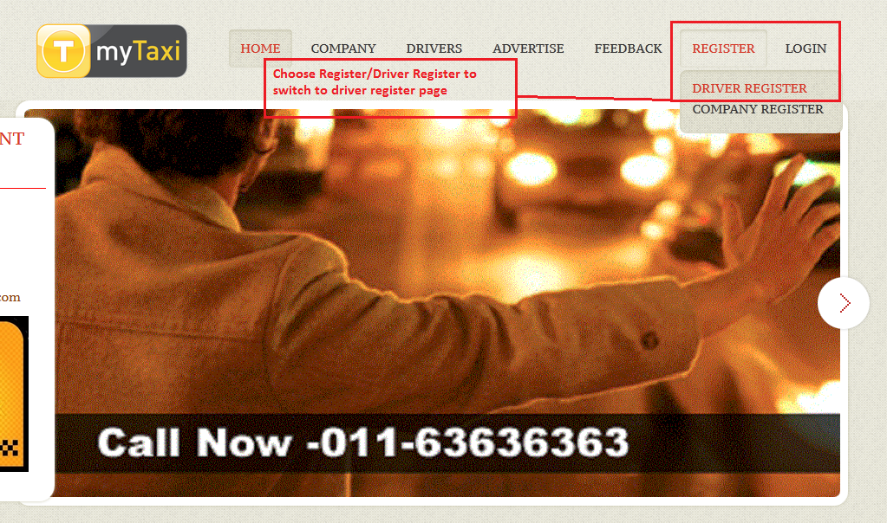

* In DriverRegister.xhtml page, fill your informations into the textboxes then click REGISTER button:

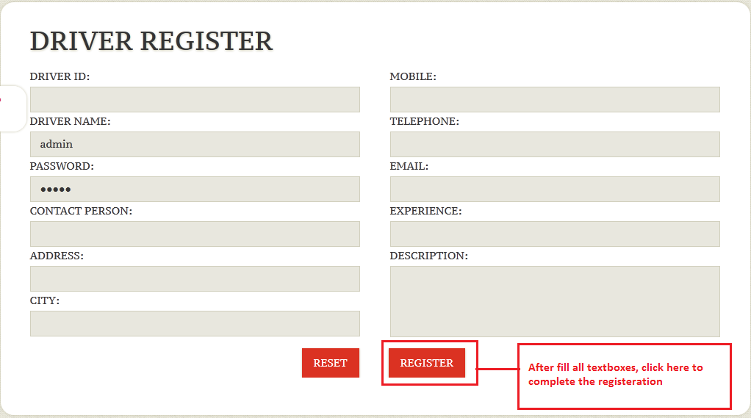

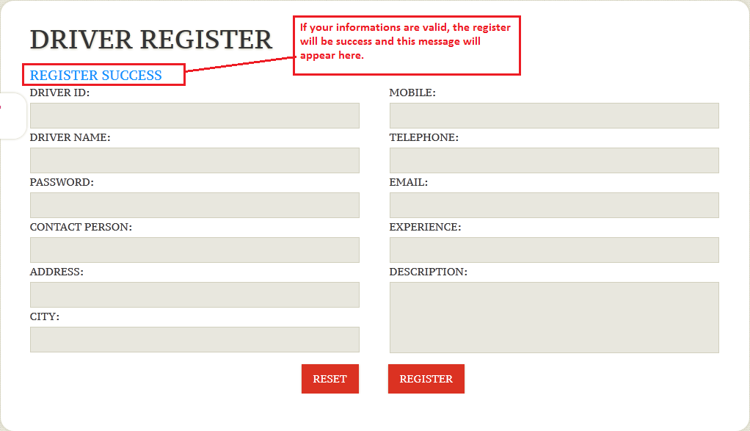

1. Driver’s Business:

* After register successfull, you can login (use your ID and Password you have just registered at previous step):

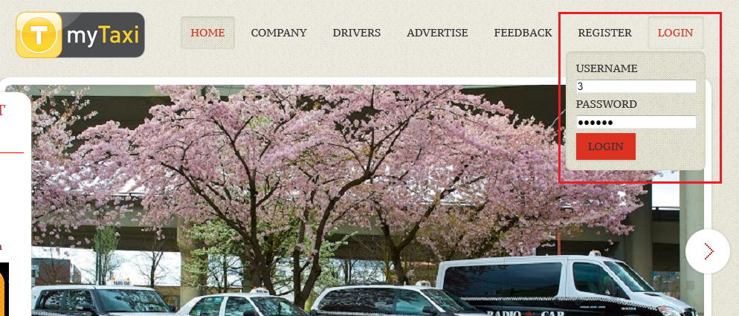

* Click Login, then you will reach to your informations’ page and you can see the toolsbar at the top-right side of screen:

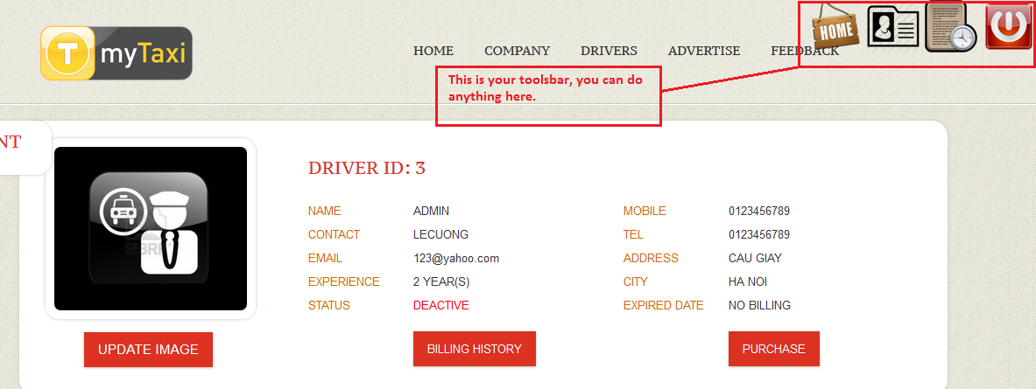

* Then, driver must purchase the first billing to active his account. Click on Purchase button, choose the Payment type and click Pay Now:

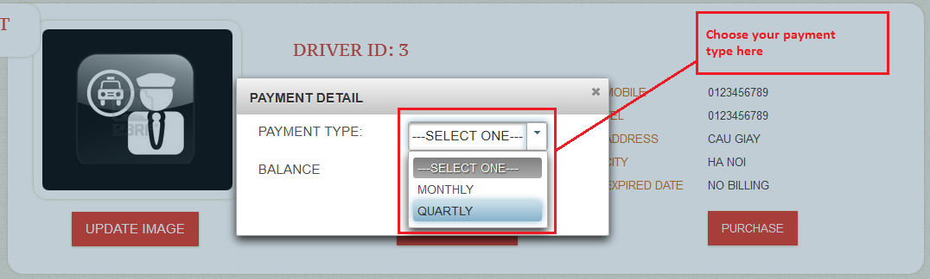

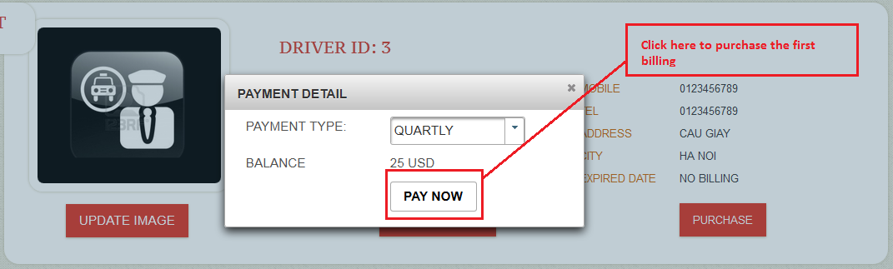

* Then, driver’s account has just been active, he can see his billing history if click Billing History button:

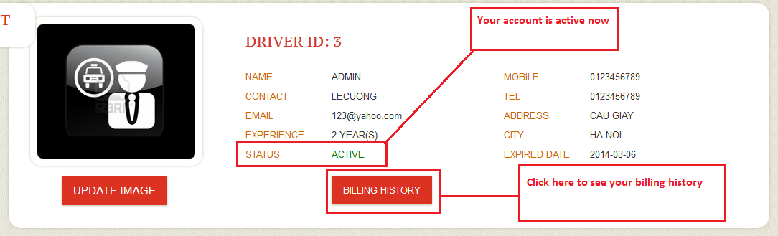

* Driver’s billing history page:

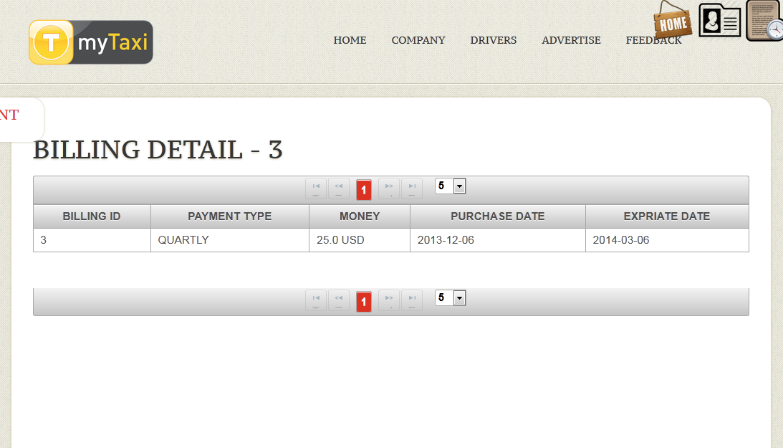

* Get back to driver’s informations page: he can update his image by click on UPDATE IMAGE button:

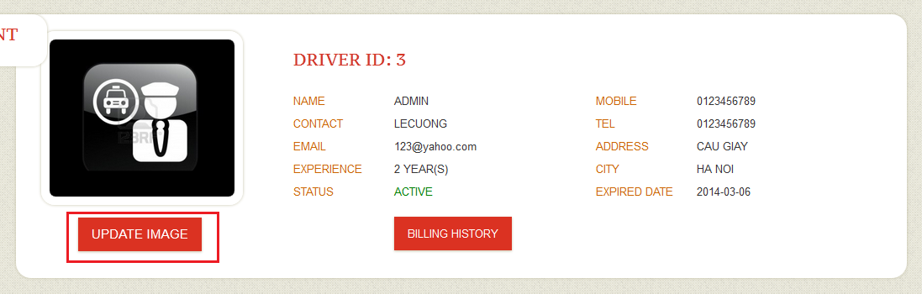

* Choose his image then click Upadate button:

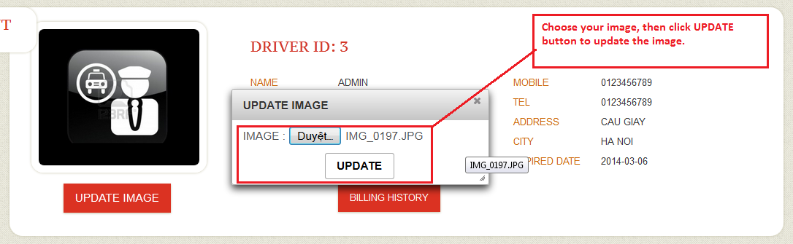

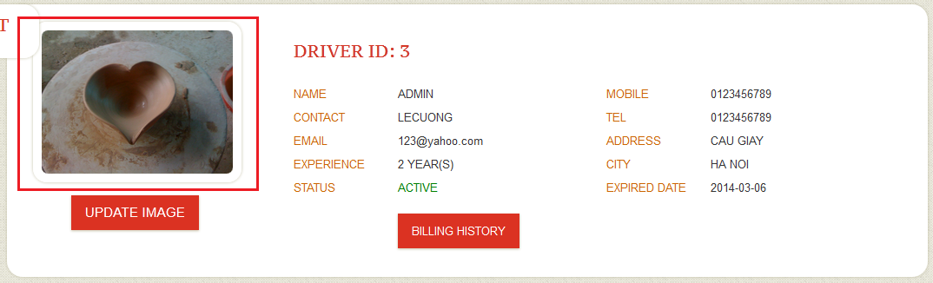

1. Company:
2. Register:

* Choose Register/Company Register on the menu to reach the company’s register page:

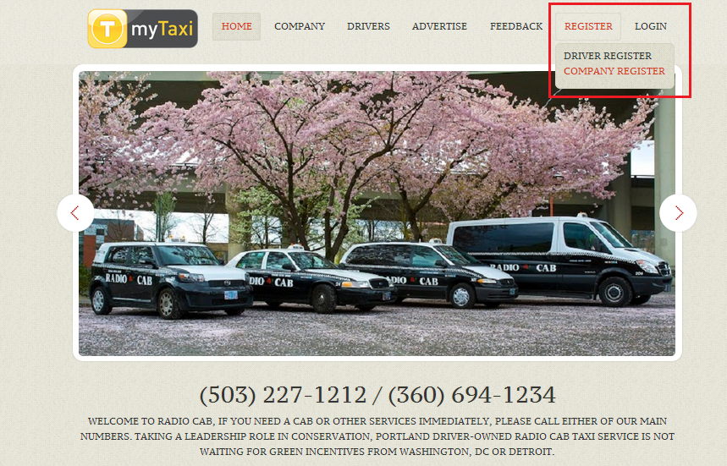

* In company’s register page, fill your informations into the textboxes then click Register button:

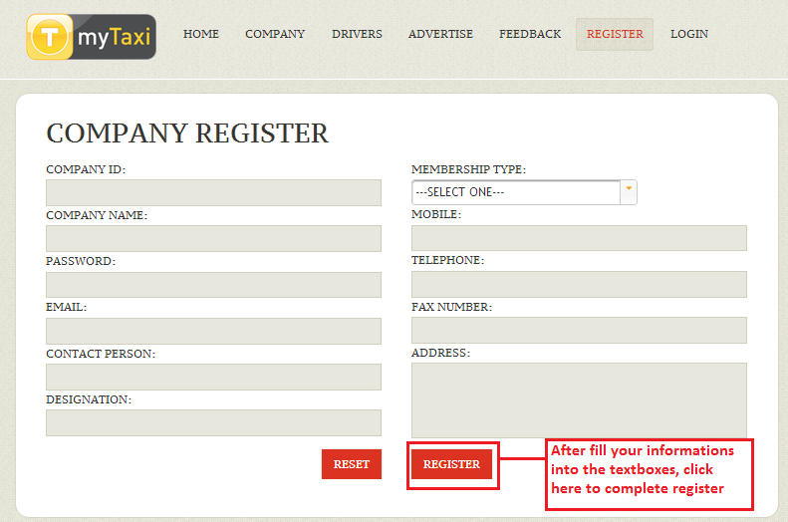

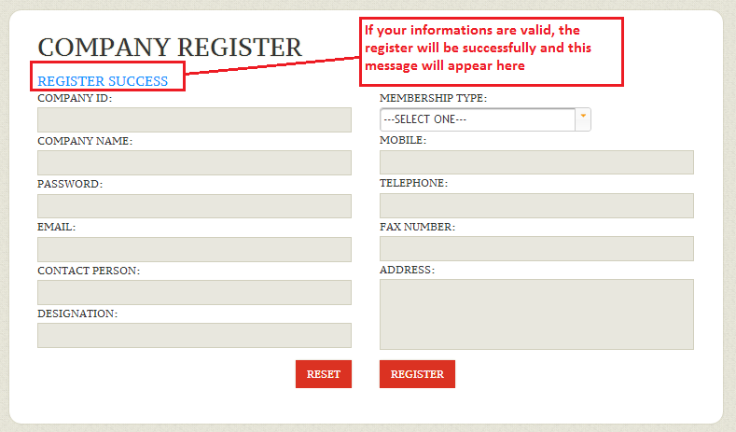

1. Company’s Business:

* After register successfull, you can login (use your ID and Password you have just registered at previous step):

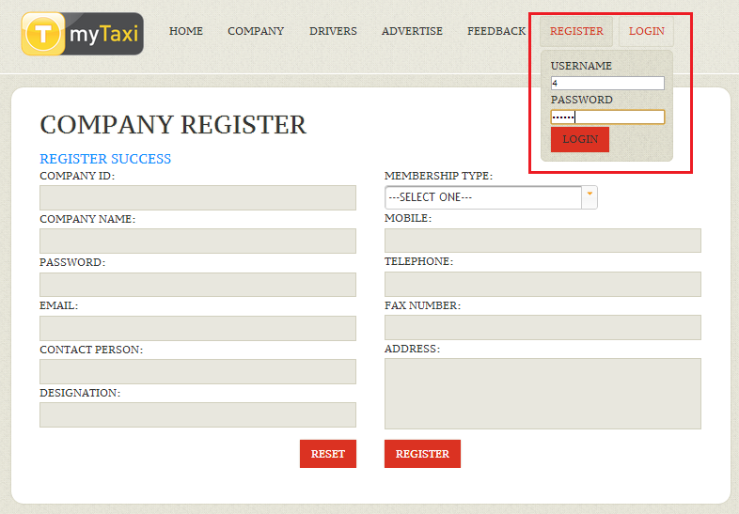

* Click Login, then you will reach to the company’s information page:

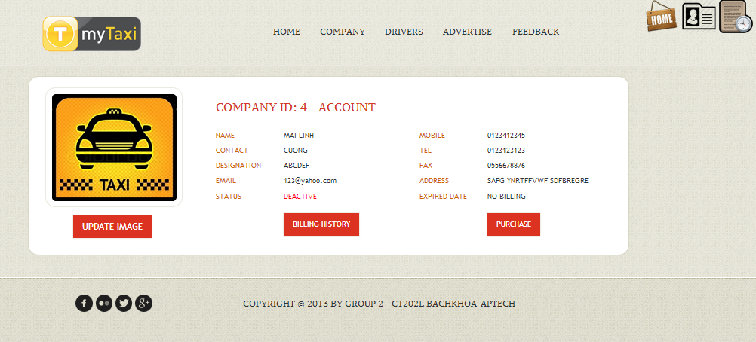

* Then, company must purchase the first billing to active his account. Click on PURCHASE button, choose the Payment type and click Pay Now:

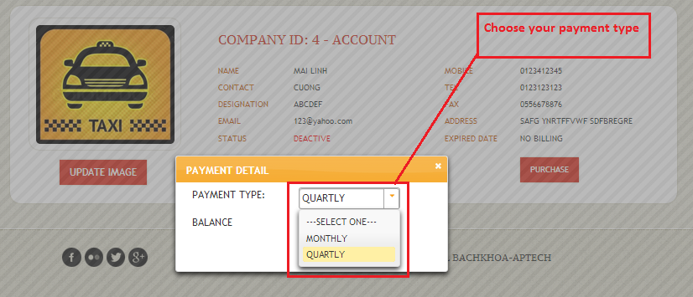

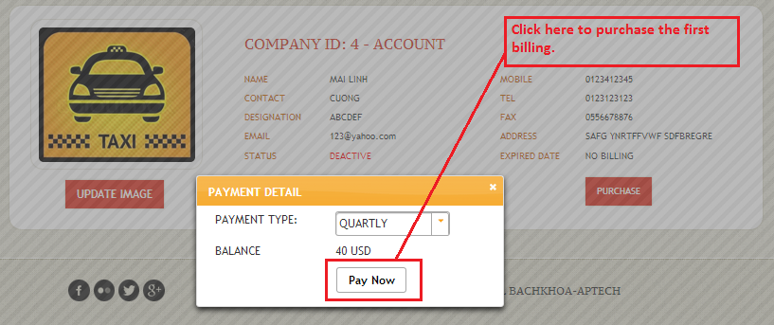

* Then, company’s account has just been active, he can see his billing history if click Billing History button:

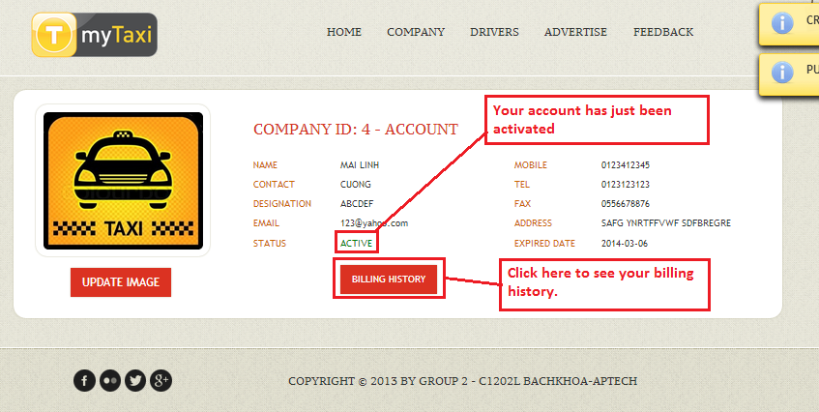

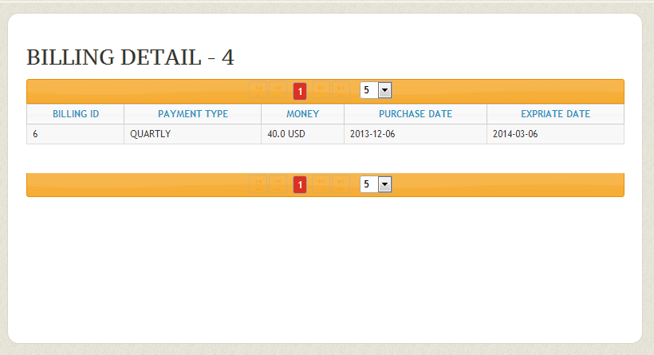

* Company can update the image by the same way with Driver (see in the previous part about the Driver’s Business).

1. Advertisements:
2. Book an advertisement:

* Choose Advertisement on main Menu:

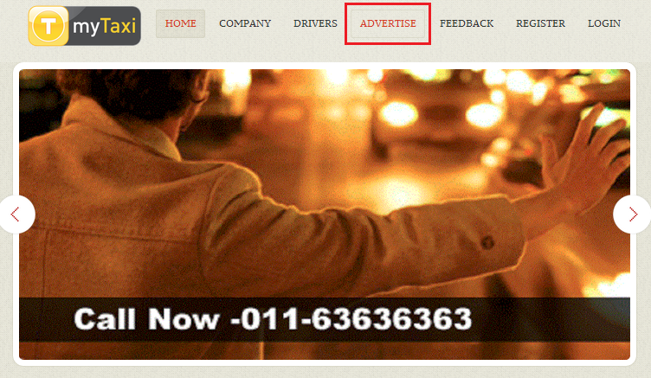

* At Advertisements’ Register page, fill all required informations into the textboxes then click Register Button:

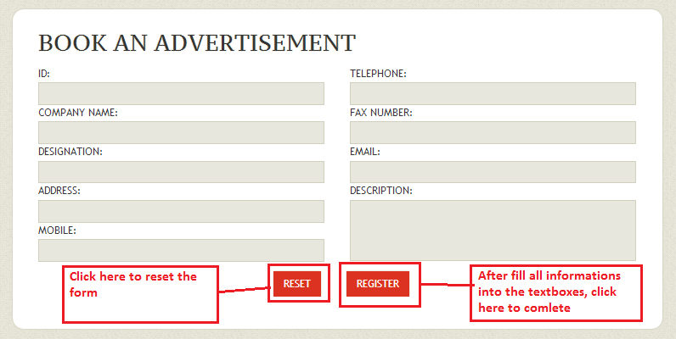

* Then, the pay form will be appeared then you must choose the Payment Type, upload the image then click on Register button to complete your booking:

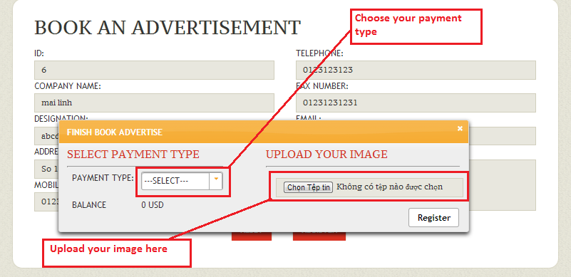

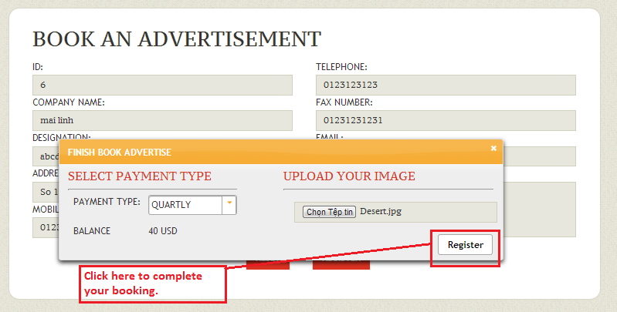

* Then, you will see your advertisement in the slide on the left screen:

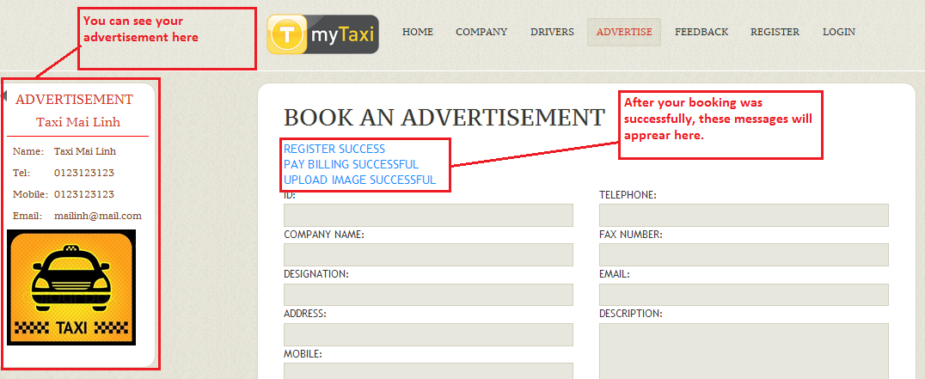

1. Feedback:

* Choose Feedback on main Menu:

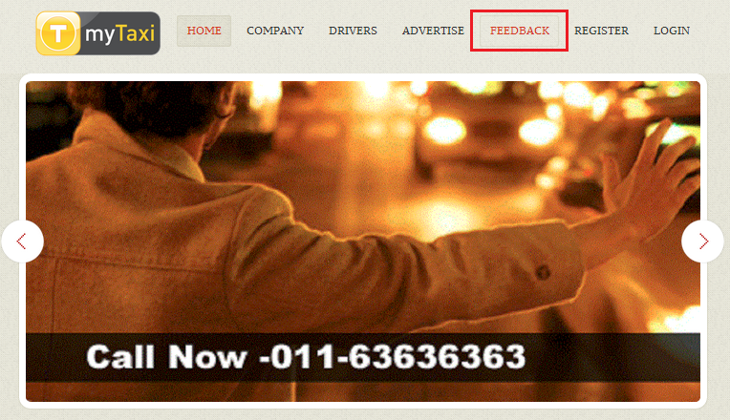

* On Feedback page, fill all the required informations then click SEND button to complete:

